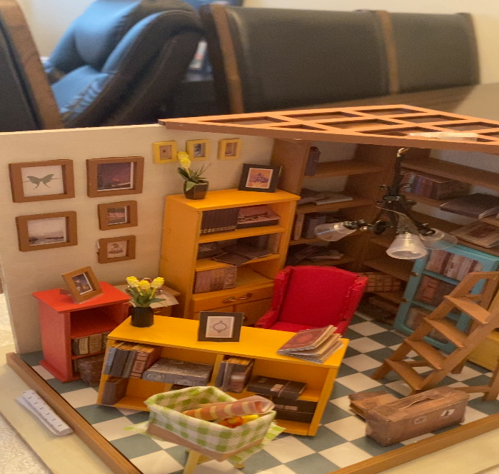
Self-Assessment | Evaluation Criteria | Teacher Assessment
- I was able demonstrate the doll housing as my hobby and clearly make the topic understandable by the audience.  - I was able to present accurate and up to date information using doll house items bought from Amazon | Knowledge and Understanding  - Demonstrates understanding of their presented topic.  - Information presented is accurate and up to date.
- I was able to demonstrate creativity by brainstorming on the topic content and present it while relaxed with an assertive tone. | Thinking and Inquiry  - Demonstrates creative thinking skills when choosing what information to incorporate and present with technological elements. | .
- I was able to introduce the subjects (my class mates) who are the audience and viewers of the content. | Communication  - Subject is introduced, viewers’  attention is captured and held,  viewers can easily follow; material is appropriate and meets the goals of the assignment.  - Explanation paragraph clearly explains student’s reasoning for choosing both topic and presentation choices.
- I was able to use visual aids to communicate ideas which also strengthen the mood, make video more accurate and effective  - I was able to make video very clear and audible for the audience and reviewers to get the concepts  - I was able to acknowledge other people’s work used  - I was able to ensure proper wording is done and use amicable grammar in explanation paragraph  - I was able to format the explanation paragraph in MLA format | Application  - Effectively uses medium to communicate ideas and information.  - Mini documentary is clear both in sound and picture.  - Student credits and cites any used sources appropriately for all information and media used.  - Proper spelling and grammar are used in Explanation Paragraph  - MLA document format used.

